Sapphires Home Learning
Respect, Trust, Friendship, Compassion, Justice and Forgiveness
We believe that Home Learning is really important. Home Learning doesn't just have to consist of Maths and English work from school. Home Learning is about spending time together as a family, enjoying different experiences and creating memories. Learning can take place EVERYWHERE. Please try to complete as many of these home learning tasks as you can and bring them into school to share with your teacher and class!
We can’t wait to see what the children make and discover!
Maths:
This term we will be spending time on the times tables as the Year 4’s have a government spelling test at the end of this term.

Year 3
Practice counting from 0 in multiples of 3, 6 and 9.
Secure the ordering of 3-digit numbers.
Practice the times tables and understand that these can help you learn related division facts.
Practice simple mental addition and/or subtraction calculations, including some 2-digit numbers.
Talk about fractions; think about what a fraction shows; how it is written; what it means; understand that it is less than 1; and place it on a number line.
Practice the vocabulary of millimetre (mm), centimetre (cm), metre (m) and kilometre (km).

Year 4
Secure column addition for numbers below 1000 but crossing the boundaries as much as possible, for example, 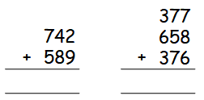

Secure column subtraction for numbers below 1000 with at least one exchange, for example,
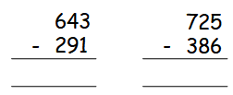

Secure the times tables and improve recall of related division facts.
Practice counting from 0 in multiples of 25, 50 and 75.
Practice using tenths and counting in tenths.
Practice counting in fractions, including beyond 1.
Practice using different fractions to make 1, for example,
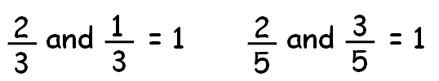

Secure equivalent fractions

Please could you also encourage your child to do their Times Tables Rockstars work at least once a week.

Reading:
Sharing book: Please read your child’s ‘sharing book’ to them daily and record in their reading diary. Please return to school daily so that your child can change this book. This book encourages language progression.

Coloured Book Band Book: your child will bring this reading book home daily. Please hear them read it and record in their reading diary. When the book is finished the children will be allowed to change the book.
Spelling:
Please continue to use the Year 3/4 spelling sheet to help your child to practice reading and spelling all the words regularly, as the children will be tested often in school as part of the No Nonsense Spelling sessions. The spelling tests will be random so the children won’t know which words we will be tested.
See separate Year 3/4 statutory spelling list.
History | Look on the internet to find proof that the Vikings came to England. Print out or write about where it was found, what the evidence was and what it proves. | 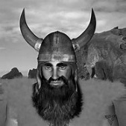
French | Create a menu for a meal; it can be breakfast, lunch or tea. Write what each food item is in French and decorate it. For example; pain is French for bread.
Art | Find the name of four pieces of art produced by William Morris.  Make a poster showing the four pieces of art that you found and don’t forget to write the name of each piece. | 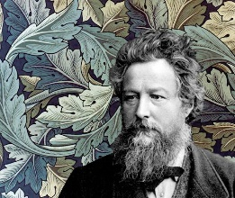
DT | Find 5 things in your food cupboards, fruit bowl or vegetable box. Find out what country they come from and work out how many miles they have travelled to get to your home. | 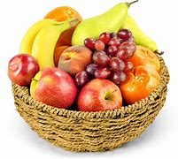
Science | Listen  - Stand outside for 5 minutes and listen very carefully. Listen for things near to you and listen out for things in the distance. Write a list of every sound that you can hear.  - Stand indoors for 5 minutes and listen very carefully. Write a list of every sound that you can hear.
RE | Find out about a festival that is part of the Islam faith. Write about when it is, why and how Islams celebrate it.
Geography | We are learning about mountains and volcanoes in Geography. Did you know that the minimum height for a mountain in the UK is 2000 feet? The average flight of stairs is 10 feet. Your challenge is to walk up 200 flights of stairs this term. Please record each time you walk up a flight of stairs or uphill using a tally chart. Once you have completed this – bring your tally chart in and we can celebrate your achievement!

