Respect, Trust, Friendship, Compassion, Justice and Forgiveness
We believe that Home Learning is really important. Home Learning doesn't just have to consist of Maths and English work from school. Home Learning is about spending time together as a family, enjoying different experiences and creating memories. Learning can take place EVERYWHERE. Please try to complete as many of these home learning tasks as you can and bring them into school to share with your teacher and class!
Maths:
Year 1 - Encourage children to recall number bonds to ten. Ask children to count in multiples of 2, 5 and 10 from 0

Year 1 – Encourage children to recall timetable facts for 2, 5 and 10 times tables. Encourage children to recall subtraction and addition facts for number bonds to 20.
Reading:
Sharing book: Please read your child’s ‘sharing book’ to them daily and record in their reading diary. Please return to school daily so that your child can change this book. This book encourages language progression and helps children to develop a love of reading.
Little Wandle Reading Book: Your child will bring home the book they have been reading in school each Friday for a ‘show off’ read to you at home. Please return this book to school on the following Monday.
Spelling: Please practice the following spellings at home:
Year 1- their, people ,oh ,you, Mr, Mrs, Miss, ask, could, would, should, our, house, mouse, water, want.
Year 2-one, once, two, again, any, many, who, whole, eye, people, journey, friend, move, improve.
Science | Can you find out about an animal habitat? It could be a desert, rainforest or a woodland area. What animals live in this habitat? What does the habitat provide the animals in order for them to live? | 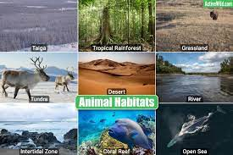
Science | Can you create a minibeast habitat?  Bring it into school or take a photo to share with us! | 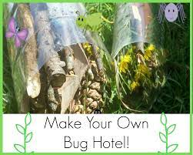
Art | Can you experiment with vegetables or fruit to create a picture using printing techniques?  Can you create different pictures with the same fruit and vegetables? | 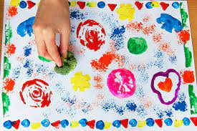
RE | What symbols of Easter can you find?  How do these symbols link with Spring and `new life`? | 